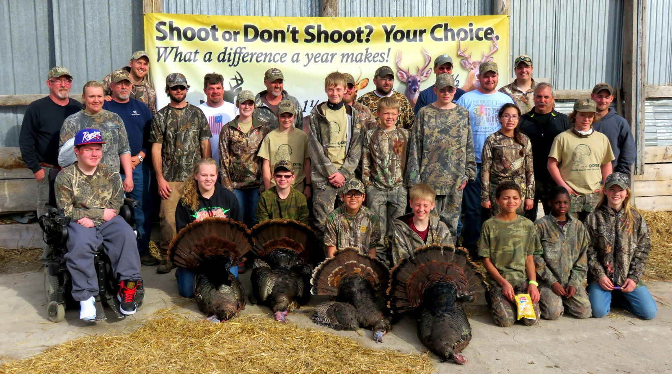
Come experience spring turkey hunting while being guided by one of our turkey hunting mentors.
Complete your essay hunting application today. We will be selecting 15 youths to participate.
Application deadline is April 1, 2018
3 easy ways to apply:
- Fill out the attached essay contest application and send via MAIL: Tyler Scott 201 Two Rivers Rd Fergus Falls, MN 56537 OR to Tyler Scott via EMAIL: scotty5-18@hotmail.com
- Go to QDMA.com/Minnesota, download the Essay contest application, email to scotty 5-18@hotmail.com
- Contact Tyler Scott with any questions or help obtaining an application @ 218-731-0623

